Please meet Roy Haines,
~Leadership Roster~
Mark Cook - Chairman of Elders  Phone: 330- 866-9375  Email: cooktrading@yahoo.com | Charlie Reed - Chairman of Deacons  Phone: 330-323-9375  Email: charliedeb@aol.com | Paul Fox, Jr. - Chairman of  the Board  Phone: 330-495-4082
better known as Fritz.


For my entire life, I have lived in East Canton and graduated from East Canton High School. I have been married to Mary for 24 years and have four daughters: Katy (senior at Malone – Pre-Med/PT), Korryn (sophomore at Mount Union – Music Ed.), Kelsey (sophomore at Malone – Zoology/Marine Biology), and Kasey (freshman at Malone – Nursing). I have been involved in the girls’ summer softball league at East Canton for 14 years. This year will be my 19th year as a driver for Robertson Heating and Supply in the Canton warehouse.

At IRCC, I am a deacon and volunteer for the nursery as well as the church custodian. In my spare time, I enjoy time with family and friends playing backyard sports (kickball, wiffle ball, softball, flag football, volleyball, etc.), going to antique tractor and car shows, and am a huge fan of “Marvel” movies and family pizza night.

Fritz Haines
~Core Doctrine Points~
We believe in Heaven and Hell.
*We believe heaven and hell are real places.
*We believe the essential difference between heaven and hell is the presence of God.
*We believe heaven is the dwelling place of God.
*We believe hell is that place locked away from the presence of God.
*We believe the dividing line for all peoples is the desire and ability to abide in the presence of God.
*We believe that those who will and can abide in the presence of God will have access to heaven.
*We believe hell is that place reserved for those who ultimately choose not to abide in the presence of God.
*We believe heaven is filled with joys forever.
*We believe hell is filled with woes and sufferings forever.

June 11, 2017
 | Attend | Offering Totals
8 a.m. Worship | 55
Sunday School | 50
Main Worship | 125 | $3,561.00
Budget Needed Weekly |  |  | $3,755.92
Faith Promise $435.00 |  |  | $875.00
Faith Promise Pledge |  |  | $18,500.00
Amount Needed Weekly |  |  | $356.00
~Building Vision Fund~
Clay Pot Amt. $3.00 |  |  | $629.00
Scrap Metal $ |  |  | $3,833.00
Paper $0 |  |  | $230.98
Debt Reduction $3.00 |  |  | $23,619.98
$98K

$95K

$90K

$85K

$80K

$75K

$70K

$65K

$60K

$55K

$50K
~Message from a Leader~

Spring is down to its last gasp and summer is upon us. Spring was busy. So will summer be. Only those spring activities which brought glory to Jesus Christ will leave a meaningful legacy. Let's spend the summer legacy building!

God Bless,
Terry Bailey

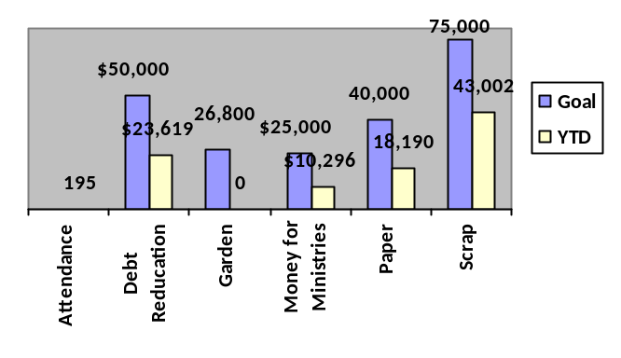



June 18, 2017
The Lord's Day
8368 Hill Church Street, SE
East Canton, Ohio 44730
330-488-2938

ircc44730@yahoo.com
www.ChristForEastCanton.com
"Like" Us on Facebook

Terry Bailey, Minister
330-904-4418
Caleb Bailey, Youth Minister
330-904-4419

Sunday Services
8:00 a.m. and 10:15 a.m. - Worship
9:15 a.m. - Sunday School
6:00 p.m. - Social Time
6:30 p.m. - Adult Bible Study
6:30 p.m. - Youth Group

Worship Leader Terry Bailey
Communion
Meditation Jim Shephard
Offering Prayer Mike Griffith
Communion
Washing Caleb Bailey
Servers
Usher Archie Sanders
Usher Craig Yoho
Usher Chris Fallot
Usher Rick Mohr
Joe Bryan
Will Picciano
Mike Griffith
Charlie Reed
Clint Thorn
Kyle Wagner
Order of Worship

Opening
Time of Silent Prayer
Scripture Mark 4:24-25

A Time for Praise
When They Ring Those Golden Bells
Jesus Savior Pilot Me

A Time for Prayer
My Latest Sun is Sinking Fast
(Please pass your Prayer Cards to the aisle)
Review of Prayer Concerns and Prayer

A Time for Preaching and Response
Special Music - Kathy Foltz
Message -
* Have You Any Room for Jesus

A Time for Remembrance

and Giving
Wonderful Grace of Jesus
(All Christians are welcome to partake)
Jesus Will Walk With Me

Closing
Announcements
Birthdays and Anniversaries
Prayer
* Just Over in the Glory Land

* Congregation please stand if able


Today's Activities
~Happy Father's Day~
6:30 p.m. - Men's Bible Study, Father's Day meal included.

Upcoming Activity Dates
June 21 at 6:30 - Christian Education Committee Meeting
June 25 - Church Picnic
July 9 -Visit from Brad Dupray of CDF
July 10-14 - VBS - Sign up today!
July 16 - Visit from 64 to Grayson

Additional Information
Pantry items for June are paper products such as paper towels, toilet paper, paper plates, etc. and cleaning supplies such as bleach, Ajax, Lysol, etc. There is a box across from the office for your donations. Thank you!

The church picnic will be June 25, rain or shine at IRCC. We will eat lunch at 12:30 pm in the barn following church services. We ask that you please bring two covered dishes to share and your own table settings. Drinks will be provided. Dress for the weather and feel free to bring your lawn chairs. Games and the waterslide will be set up.

July 18 at 6:00 Fireside Chat - meal and childcare provided - New members and those interested in becoming members attend this third session to explain our congregation's doctrine, programs vision and structure.

Card making workshop will be on June 28 from 10am to 2pm. All ladies are welcome. If you have any questions, please contact Mary Sanders at 330-323-7809.
2017 VBS
July 10-14
6-8:30 pm
VBS registration cards are available on the table. You may also register online at www.christforeastcanton.com, IRCC Facebook messenger or call the church office.

Continuing Needs
Jim Beavers
Dick Borne
Helen Cross
Mark Demos
Sue Halsey
Darlene Krider
Kathy Mitchell
Steve Phillips
Sophia Rae
Savannah
Annika Shankle
Reagan Terry
Tim Thorn
Logan Trizna
Bertha Unkefer
Denise VanVoorhis

Prayer List
Betsy Abertoni
Inez Anderson
Jackie Anthony
Baby Mae
Dale and Ella Bailey
Bob & Pat Barnhouse
Jodi Beavers
Ethan Bennett
Lisa Berger
Willard Berkebile
Greg Biedenbach
Lola Brewer
Sam Cartwright
Family of Eileen Conrad
Berry Cox
Jane Long Dye
Family of Lee Farnsworth
Jay Fisher
Family of Bill Foltz
David Helmick
Jesse Labus
Pam Long
Marion Lowery
Manny Nieto
Tom Parker
Sherri Oberly
Barb Posatiere
Resendez Family
Amanda Rinehart
Derek Rodriguez
Archie Sanders
Sharon Savage
Elmer Snider
Jack Spencer
Bessie Stanojevic
Nolan Taylor
Kim Tekip
Bryan Wilson

Nursing Homes

Ethel Adkins – St. Joseph’s
Joyce Carroll -Canton Christian Home
Carolyn King - Hospitality House
Marion Lowery - St. Joseph's
Gary Young

